**Project Title: Earthquake Prediction Model Using Python**

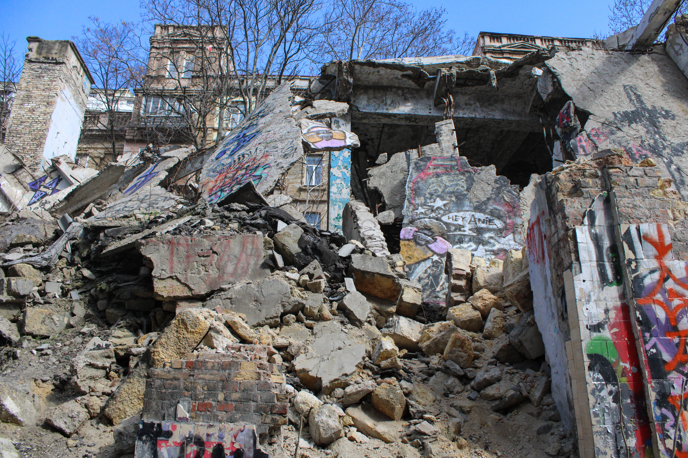

**Abstract:**

The Earthquake Prediction Model project aims to leverage data wrangling techniques and neural network algorithms to predict earthquake occurrences. Earthquakes are natural disasters with significant socio-economic impact, and early prediction can save lives and reduce damage. This project explores the development of a predictive model using Python, combining data preprocessing, feature engineering, and machine learning.

**Table of Contents:**

Introduction

Background and Motivation

Objectives

Significance of Earthquake Prediction

Data Collection

Data Sources

Data Retrieval

Data Description

Data Preprocessing

Data Wrangling

Data Cleaning

Handling Missing Values

Data Transformation

Feature Selection

Exploratory Data Analysis (EDA)

Visualizing Geospatial Data

Statistical Summaries

Correlation Analysis

Feature Engineering

Creating New Features

Normalization and Scaling

Encoding Categorical Data

Machine Learning Models

Introduction to Neural Networks

Model Selection

Model Architecture

Model Training

Model Evaluation

Hyperparameter Tuning

Results and Analysis

Evaluation Metrics

Model Performance

Visualization of Predictions

Insights and Interpretation

Discussion

Challenges Faced

Future Improvements

Real-world Applications

Conclusion

Summary of Findings

Implications

References

Cite relevant literature, datasets, and libraries

Appendices

Code snippets

Additional data or figures

Module Descriptions:

Data Collection

Use web scraping, APIs, or datasets to gather earthquake-related data. This may include historical earthquake data, geographical information, and seismic measurements.

Data Wrangling

Clean and preprocess the collected data. Handle missing values, remove duplicates, and ensure data quality.

Exploratory Data Analysis (EDA)

Visualize and explore the data to gain insights. Analyze patterns, correlations, and anomalies in the earthquake data.

Feature Engineering

Create new features from the existing data, normalize, and scale the data. Encode categorical variables for machine learning.

Machine Learning Models

Implement neural network models for earthquake prediction. Train and evaluate these models using appropriate metrics.

Results and Analysis

Present the model's performance, discussing how well it predicts earthquakes. Visualize the results for better understanding.

Discussion

Reflect on the challenges faced during the project, propose future improvements, and suggest real-world applications of the earthquake prediction model.

Conclusion

Summarize the key findings and the significance of the project in the context of earthquake prediction.

**CODING MODULES:**

import warnings

import time

import traceback

import numpy as np

import pandas as pd

from scipy import stats

import scipy.signal as sg

import multiprocessing as mp

from scipy.signal import hann

from scipy.signal import hilbert

from scipy.signal import convolve

from sklearn.linear_model import LinearRegression

from sklearn.preprocessing import StandardScaler

import xgboost as xgb

import lightgbm as lgb

from sklearn.model_selection import KFold

from sklearn.metrics import mean_squared_error

from sklearn.metrics import mean_absolute_error

from tqdm import tqdm

warnings.filterwarnings("ignore")

**1. Data Collection:**

Description: This module is the foundation of your project. It involves gathering the necessary data for your earthquake prediction model. Data can come from various sources, such as public datasets, APIs, government agencies, or web scraping. You may need historical earthquake data, geological information, seismic sensor readings, and other relevant data.

**Tasks:**

Identify appropriate data sources.

Extract data from these sources.

Ensure data integrity and quality.

Store the collected data in an organized format.

def split_raw_data():

df = pd.read_csv(os.path.join(DATA_DIR, 'train.csv'))

max_start_index = len(df.index) - SIG_LEN

slice_len = int(max_start_index / 6)

for i in range(NUM_THREADS):

print('working', i)

df0 = df.iloc[slice_len * i: (slice_len * (i + 1)) + SIG_LEN]

df0.to_csv(os.path.join(DATA_DIR, 'raw_data_%d.csv' % i), index=False)

del df0

del df

**2. Data Wrangling:**

Description: Data wrangling is the process of cleaning and preparing the collected data for analysis and modeling. This module focuses on making the data usable for predictive modeling by handling missing values, outliers, and other data issues.

**Tasks:**

Data cleaning: Remove or correct errors and inconsistencies in the data.

Handle missing values: Decide on imputation strategies.

Data transformation: Normalize, scale, and format the data appropriately.

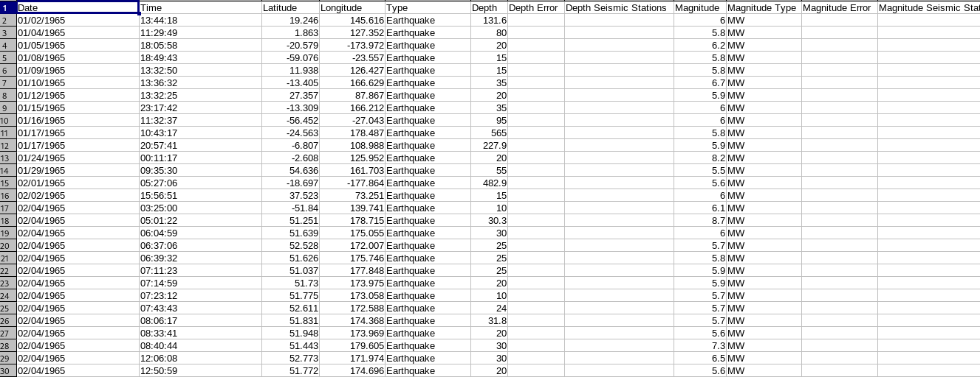Feature selection: Choose the most relevant features for prediction.

**3. Exploratory Data Analysis (EDA):**

Description: EDA involves visually and statistically analyzing the preprocessed data to gain insights. It helps you understand the data's characteristics, distribution, and relationships, which can inform feature engineering and modeling decisions.

**Tasks:**

Visualize geospatial data: Plot earthquakes on maps and visualize their distribution.

Generate statistical summaries: Calculate means, standard deviations, and other relevant statistics.

Correlation analysis: Explore the relationships between variables using correlation matrices and scatter plots.

def build_fields(proc_id):

success = 1

count = 0

try:

seg_st = int(NUM_SEG_PER_PROC * proc_id)

train_df = pd.read_csv(os.path.join(DATA_DIR, 'raw_data_%d.csv' % proc_id), dtype=

{'acoustic_data': np.int16, 'time_to_failure': np.float32})

len_df = len(train_df.index)

start_indices = (np.loadtxt(fname=os.path.join(OUTPUT_DIR, 'start_indices_4k.csv'), dtype=

np.int32, delimiter=','))[:, proc_id]

train_X = pd.DataFrame(dtype=np.float64)

train_y = pd.DataFrame(dtype=np.float64, columns=['time_to_failure'])

t0 = time.time()

for seg_id, start_idx in zip(range(seg_st, seg_st + NUM_SEG_PER_PROC), start_indices):

end_idx = np.int32(start_idx + 150000)

print('working: %d, %d, %d to %d of %d' % (proc_id, seg_id, start_idx, end_idx, len_df))

seg = train_df.iloc[start_idx: end_idx]

# train_X = create_features_pk_det(seg_id, seg, train_X, start_idx, end_idx)

train_X = create_features(seg_id, seg, train_X, start_idx, end_idx)

train_y.loc[seg_id, 'time_to_failure'] = seg['time_to_failure'].values[-1]

if count == 10:

print('saving: %d, %d to %d' % (seg_id, start_idx, end_idx))

train_X.to_csv('train_x_%d.csv' % proc_id, index=False)

train_y.to_csv('train_y_%d.csv' % proc_id, index=False)

count += 1

print('final_save, process id: %d, loop time: %.2f for %d iterations' % (proc_id, time.time() - t0, count))

train_X.to_csv(os.path.join(OUTPUT_DIR, 'train_x_%d.csv' % proc_id), index=False)

train_y.to_csv(os.path.join(OUTPUT_DIR, 'train_y_%d.csv' % proc_id), index=False)

except:

print(traceback.format_exc())

success = 0

return success # 1 on success, 0 if fail

**4. Feature Engineering:**

Description: Feature engineering is the process of creating new features from the existing data or transforming features to improve the model's performance. It helps the model better capture underlying patterns and relationships.

**Tasks:**

Create new features: Combine, derive, or extract features that may be informative.

Normalization and scaling: Ensure all features are on the same scale.

Encoding categorical data: Convert categorical variables into numerical representations (e.g., one-hot encoding or label encoding).

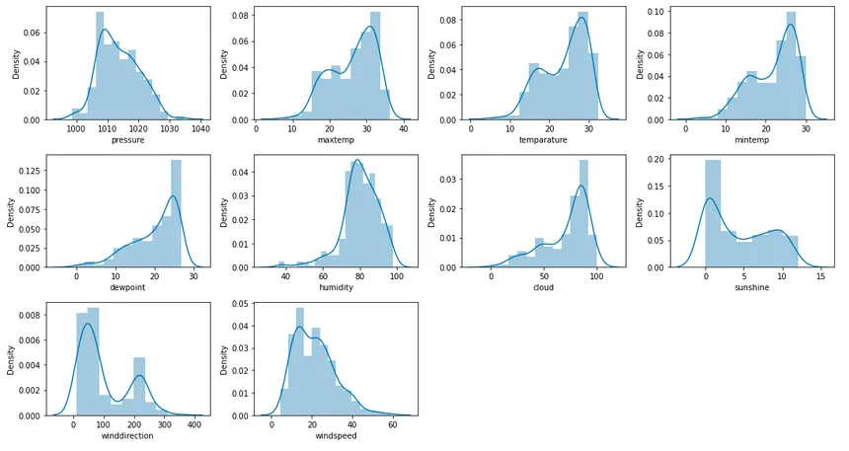

**5. Machine Learning Models:**

Description: This is the heart of your project, where you implement the neural network-based earthquake prediction model. You'll choose the appropriate model architecture, train it on the prepared data, and evaluate its performance.

**Tasks:**

Introduction to Neural Networks: Provide an overview of neural network concepts.

Model Selection: Choose the neural network architecture suitable for your problem.

Model Architecture: Define the layers and structure of your neural network.

Model Training: Train the neural network on the preprocessed data.

Model Evaluation: Assess the model's performance using appropriate evaluation metrics.

Hyperparameter Tuning: Optimize the model's hyperparameters to improve its performance.

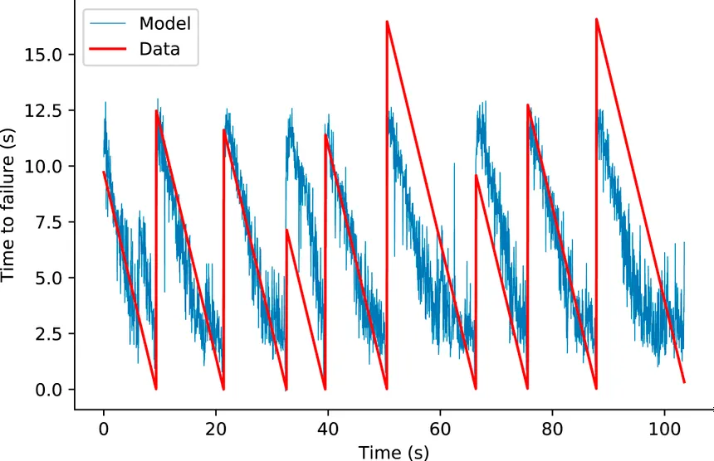

**6. Results and Analysis:**

Description: In this module, you will present the outcomes of your earthquake prediction model. This includes evaluating the model's performance, visualizing the predictions, and providing insights into what the model has learned.

**Tasks:**

Evaluation Metrics: Explain the metrics used to assess the model's performance (e.g., accuracy, F1 score).

Model Performance: Discuss how well the model predicts earthquakes based on the chosen metrics.

Visualization of Predictions: Create visualizations to illustrate the model's predictions.

Insights and Interpretation: Provide insights into the patterns or features the model has identified as important for earthquake prediction.

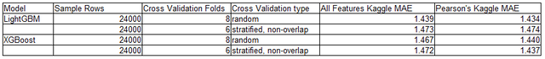

**7. Discussion:**

Description: This module focuses on the challenges faced during the project, potential improvements, and real-world applications of your earthquake prediction model.

**Tasks:**

Challenges Faced: Reflect on difficulties encountered and how they were addressed.

Future Improvements: Suggest enhancements or directions for future work.

Real-world Applications: Discuss how this model could be used in practical earthquake prediction scenarios.

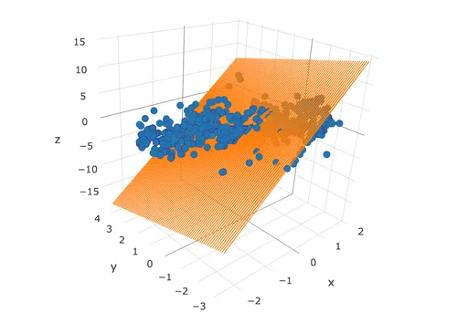

**8. Conclusion:**

Description: Summarize the key findings and the project's overall significance in the context of earthquake prediction. Reiterate the importance of the work done and the potential impact on disaster mitigation.